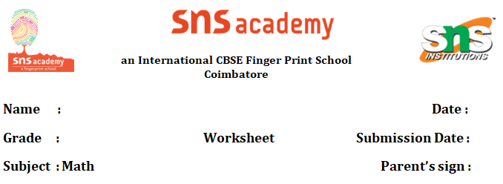

**Data Handling**

**Case study Questions**

## Case Study 1: School Library Book Survey

**Scenario**: A school librarian conducts a survey to find out the favorite book genres among 40 Grade 7 students. The results are: Fiction (15 students), Mystery (10 students), Science Fiction (8 students), and Non-Fiction (7 students).

1. Organize the data in a frequency table.
2. Calculate the percentage of students who prefer Fiction. Express your answer as a decimal rounded to two places.
3. Draw a bar graph to represent the data. (Describe the steps or sketch the graph.)
4. What is the mode of the data, and what does it tell you about the students' preferences?

## Case Study 2: Weather Observation

**Scenario**: A Grade 7 class records the daily temperature (in °C) for one week: Monday (22), Tuesday (24), Wednesday (20), Thursday (23), Friday (25), Saturday (21), Sunday (23).

1. Calculate the mean temperature for the week. Show your calculations.
2. Find the median temperature after arranging the data in ascending order.
3. What is the range of the temperatures recorded?
4. If the class wants to represent this data using a line graph, explain how they should set up the axes and plot the points.

## Case Study 3: Class Test Scores

**Scenario**: A math teacher records the test scores (out of 50) for a class of 10 students: 45, 38, 42, 50, 36, 40, 44, 39, 47, 41.

1. Organize the scores into a frequency table using intervals (e.g., 36–40, 41–45, 46–50).
2. Calculate the mean score of the class. Round your answer to one decimal place.
3. Draw a histogram to represent the data. (Describe the steps or sketch the histogram.)
4. If the teacher wants to award a prize to students who scored above the mean, how many students will receive the prize?

## Case Study 4: Sports Day Participation

**Scenario**: During a sports day, 50 students participate in different events. The number of students in each event is: Running (20), Long Jump (12), Relay (10), and Shot Put (8).

1. Represent the data using a pie chart. Calculate the angle for each event. (Hint: Total angle = 360°.)
2. What fraction of students participated in Running? Simplify your answer.
3. Convert the fraction from question 2 into a percentage.
4. Which event had the least participation, and what does this suggest about the event’s popularity?

## Case Study 5: Pocket Money Savings

**Scenario**: Five friends track their weekly pocket money savings (in dollars): Ali ($5.50), Bella ($7.00), Charlie ($4.50), Dana ($6.00), and Emma ($5.00).

1. Calculate the average amount saved by the friends. Show your calculations.
2. Find the median savings amount after arranging the data in ascending order.
3. If Bella saves $7.00 again next week, how will it affect the mean savings of the group?
4. Represent the data using a bar graph. (Describe the steps or sketch the graph.)